STARS
Process for Evaluating Registration in Fused Track/ADS-B in STARS
Air Traffic Organization Terminal Field Operational Support (TFOS) Terminal Surveillance Performance & Registration Group
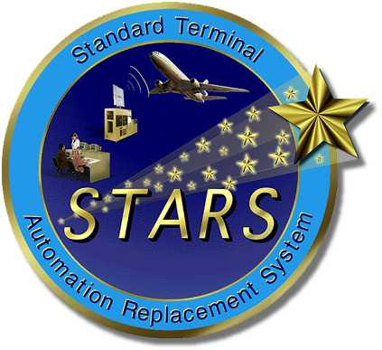
Process for Evaluating Registration in Fused Track/ADS-B in STARS

This process includes the steps necessary to evaluate registration at a facility ready to implement fused track mode and the addition of the ADS-B sensor. This does not include adding additional radars that are not currently utilized at the site.

Why do we need this process?
STARS had registration in previous builds, however it was a manual process and the tolerances for registration were also wider.

 | Non-Fused | Fused mode
Range | + or - 760 feet | + or – 190 feet
Azimuth | + or – 2 acps | + or – 1 acp

With fusion, there are new SBS requirements that are ½ the value for azimuth and ¼ the value for range then they were in Non fused mode. Also the registration algorithm changed. The process has now become automated with visual indications to the controllers and tech ops when the new requirements are not being met.

All STARS sites were evaluated for Non-fused registration specifications prior to and after the sites became operational on their STARS software. Currently there is a performance check in the STARS handbook that requires the sites to check their registration corrections daily.

Why does this matter NOW?
In fused track mode all of the data from each sensor is collected and may contribute to one display. Previously, in non fused mode, everything was relative, if a sensor was rotated 2 acps, everything would move 2 acps. The distances between tracks would remain the same.

In fused track display there has to be an “agreement” between radars on where a target is located. Which would make that 2 acp rotation no longer relative but possibly disruptive. Radar registration verifies that this “agreement” is meeting the SBS requirement. If it is not, than there is a higher chance for tracking anomalies to be displayed in fused track mode (split targets, duplicate beacon codes, ghost tracks, false conflict alerts, targets jumps and stitching).

On the next page are examples of what registration does:

This is UNCORRECTED data for a single track

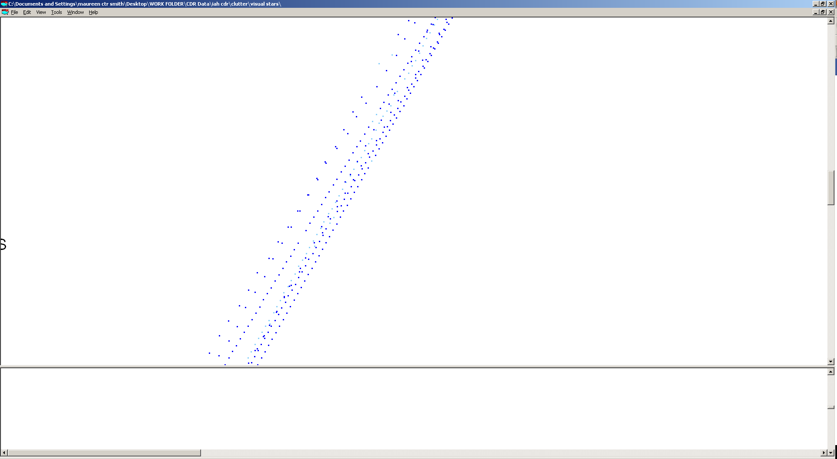
This is the CORRECTED data for that same track

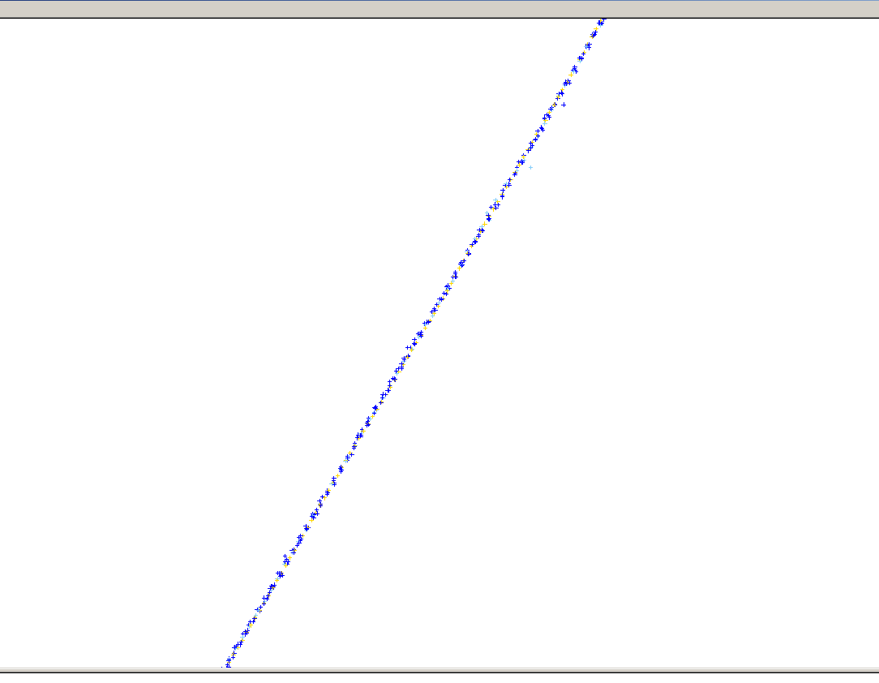

This is a CORRECTED target report that is within NON Fused mode specifications, but NOT within fused mode specifications.

*** These are the issues that need to be identified and fixed prior to fused mode implementation.

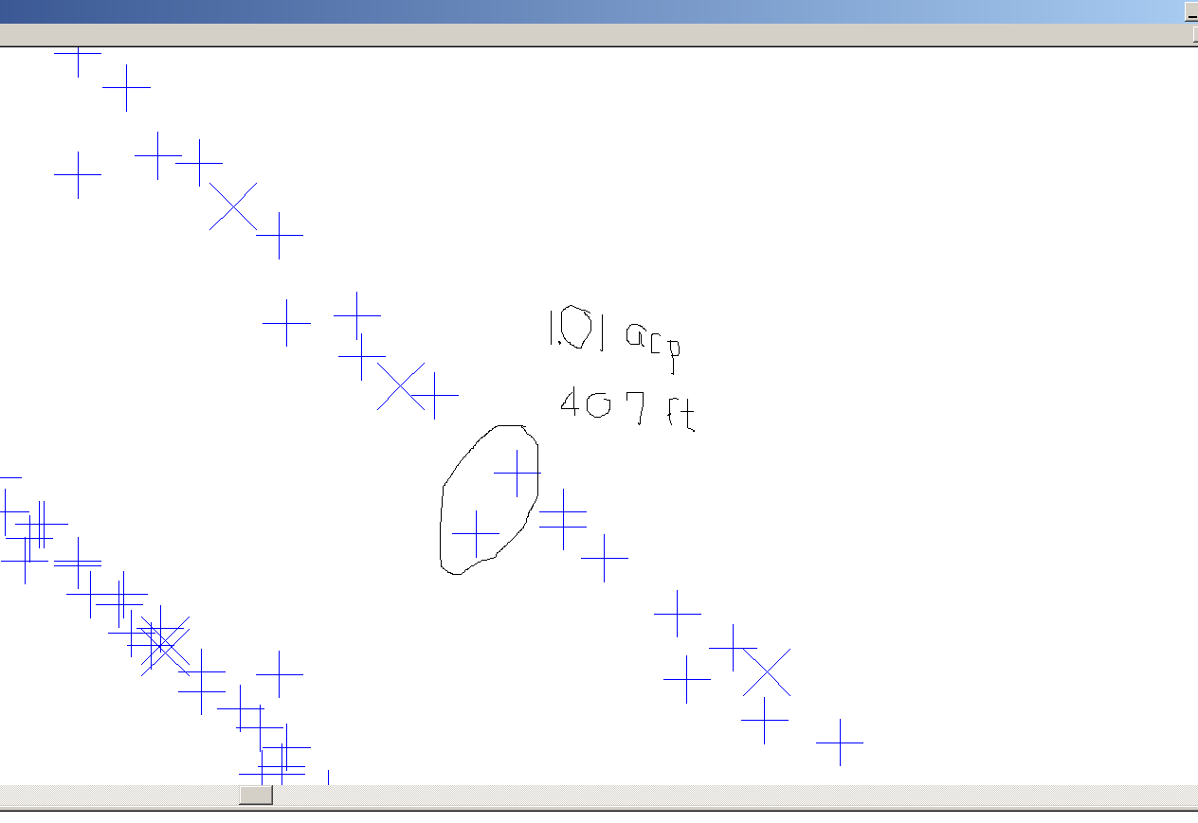

The above example illustrates that registration can’t fix all “disagreements” between radars.

What is done to evaluate registration for fused track display?

Sensor Data Verification
- Collect latest adaptation parameters for:
  - Lat/long data
  - North angle correction
  - Default registration corrections for range and azimuth
  - Adapted radar pairs
- Visually check radar positions
  - Enter lat/long positions into Google earth, verify lat/longs are on radar antenna or dome.
  - IF visual check is good move to step 3
  - IF visual check is in question, request official site survey information for affected radars
  - If data from official site survey matches adaptation, further investigation is needed, contact radar group for support.
  - If data from official site survey is different from site adaptation, visually check official survey data, apply to site adaptation.

Why do we need to perform this action?
It has been our experience that there have been differences in the actual position of the radar and the adapted/site survey position of the radar. This error will affect the registration solution.

FOR EXAMPLE: This is a radar that is adapted approx 250 feet from its actual position. In this case we would request the positional data be reviewed. (Note that fused track tolerances are + or – 190 feet)
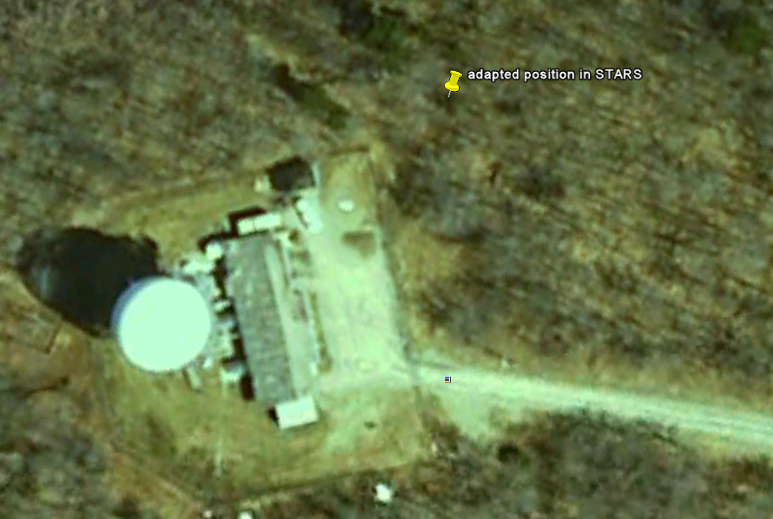

NOTE : any changes to the radar position, North angle correction or alignment work done to the radar will impact registration. Steps 1 and 2 may need to be repeated for correct radar adaptation data for each radar adapted at the site if these changes are necessary.

After the proper location of the radars are verified:

Data collection and analysis/corrective action implementation.
- Collect registration reports, parrot/pe reports from site (10 days worth)
  - Verify site meets Fused mode tolerances for operation (refer to 6191.3a change 1 for instructions)
  - If it does NOT meet the tolerances for fused mode operations, corrective action will be needed. This may include evaluation of certain adaptation parameters, or coordination between the site, radar group and automation specialist.
- Collect CDR data from site (if no live feeds are available in TC labs). Request 4 or more 2 hour slices of CDR data from busiest traffic times, (Radars cannot be FAILED during recorded times)
  - Convert this data to SDRR data and store it on the corresponding SIRS box to be played back in the labs
- Upgrade operational database to fused mode build (check with OSF) and load on to string in lab to evaluate auto registration and fused mode presentation. Ensure correct adapted values for all registration adaptation parameters.

- If this step is performed too soon in the process it would require this process to be repeated several times over. Many parameters changed during the adaptation optimization process for adapting fused track mode for operational could affect registration. Also, currently the STARS software drop witch incorporates more fixes for automatic registration (STR 21689) is NOT available to evaluate. This step cannot be performed until that software is made available.

- Run fused track build in labs with collected CDR data. Ensure proper presentation of targets and test targets on TCW, evaluate Automatic registration, evaluate registration reports, and proper MCW radar indications.
  - Utilize CDR recordings from the labs to check registration corrections utilizing visual STARS.
  - Verify site meets Fused mode tolerances for operation (refer to 6191.3a change 1 for instructions)
  - If it does NOT meet the tolerances for fused mode operations, corrective action will be needed. This may include evaluation of certain adaptation parameters, or coordination between the site, radar group and automation specialist. ( repeat steps 3-6)

NOTE: Steps 5-6 may need to be repeated multiple times to check various changes to adaptation parameters until a good recommendation is found.

Recommendation Report
- Prepare Registration recommendations for Default registration values, registration operating mode, adapted pairs, and other adaptable registration values. Provide these values to the OSF for inclusion into the test and operational fused builds.

